News

Congratulations
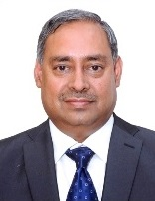
Sri Anil Kumar Jha took over as Chairman of Coal India Ltd. Mr. Anil Kumar Jha took over the charge of Chairman-cum-Managing Director (CMD) Coal India Limited on May 18, 2018. Mr. Anil Kumar Jha was Chairman-cum-Managing Director (CMD) Mahanadi Coalfields Limited (MCL), a leading subsidiary of Coal India Limited from November 1, 2015.
He holds M. Tech. in Mine Planning & Design from the Indian School of Mines, Dhanbad, with distinction. He comes with a rich work experience spanning 35 years in the field of mine planning, production, management supervision, direction and control of underground as well as open cast coal mines. He has worked with Central Mine Planning & Design Institute Limited (CMPDI), Ranchi, for 14 years, planning both opencast and underground mines. After joining Coal India Limited at the Central Coalfields Limited (CCL) in July 1983, he rose rapidly and has handled various senior positions rising to become the Director (Production & Planning) of MOIL Limited, who is Nominated Owner and Head of Production, Planning, Projects, Quality Control and Mine Safety Divisions and other allied departments including Personnel and Industrial Relations Department. He has also undergone a 3 week training programme in Australia in May 1991 on various opencast and UG projects, safety and research institution, equipment manufacturer’s facilities and introduction of new technologies. He has attended International Seminar on Project Management in Finland and also attended advanced training programme on mining in China in September, 2010.
The IME Journal family extends him a very hearty congratulations. We expect that he will meet the expectation of the entire country by leading Coal India to achieve greater heights in production, opening up of new underground coal mines, reducing cost of mining, improving availability of resources through sustainable management.

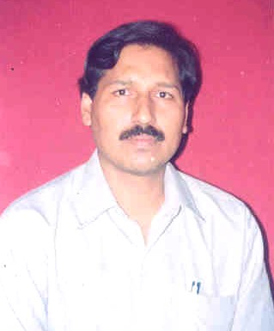 Prof T.N.Singh took over as Vice Chancellor of Mahatma Gandhi Kashi Vidyapeeth. An eminent earth scientist and Mining, he is also member of our Editorial Board.
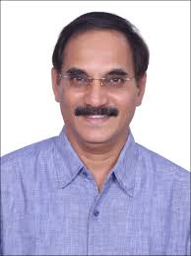 Dr H.S.Venkatesh took over as Director of NIRM, Kolar. An expert in rock excavation and blasting had several years of experience in Mining and allied rock excavation activities

